
Contents
1. Title 2
2. Inventors 2
3. Report Prepared by 2
4. Brief Summary of the Invention 2
5. Features/ Steps in the Invention 3
6. List of Prior Arts 3
7. Mapping of Prior Arts 4

Title
AI based Web Application Crawler for Automated UI Test Generation
(IP Team Reference number - PAT-2026-QEA-010733)

Inventors
- Rajhasekarun Ganapathy Damodaran - rajhasekarun.g.d@gmail.com

Report Prepared by
- Jojy George Koduvath

Brief Summary of the Invention

The invention relates to an AI-driven, intent-aware web application crawler that autonomously discovers, models, and validates user interface workflows to generate maintainable UI automation assets. Unlike conventional test automation frameworks that depend on manually authored scripts, predefined navigation sequences, or hard-coded element locators, the proposed system employs a real browser to dynamically interpret application states, identify interactive elements, and traverse application workflows based on user intent. A deterministic decision engine selectively invokes a Large Language Model (LLM) only when conventional rule-based reasoning and cached knowledge are insufficient, thereby reducing AI inference overhead while maintaining autonomous exploration. The crawler systematically constructs a versioned knowledge graph representing application pages, UI states, transitions, and metadata, which serves as the foundation for automated test generation and future incremental exploration.
A key novelty of the invention lies in its combination of deterministic exploration with adaptive AI reasoning. The system introduces deterministic branch replay to exhaustively explore alternative navigation paths without repeatedly invoking the LLM, thereby improving exploration efficiency and consistency. It further distinguishes multiple application states sharing the same URL using a composite structural fingerprint derived from interactive elements, DOM hierarchy, and layout characteristics, enabling accurate identification of dynamic Single Page Application (SPA) states. The invention also incorporates confidence-based decision making, multi-strategy locator generation, prioritized field-value resolution, adaptive exploration prioritization, and continuous learning from execution feedback, allowing validated decisions to be reused across subsequent crawls while progressively improving automation accuracy and reducing maintenance effort.
The inventive step resides in the integration of these technical mechanisms into a unified autonomous crawling framework that continuously evolves with the target application. Rather than functioning as a conventional AI-assisted testing tool, the invention maintains an incrementally updated knowledge graph capable of detecting application changes, performing delta-based re-crawling, and regenerating resilient Page Object Models (POMs) and test artifacts across multiple programming languages from a single application model. The coordinated use of selective LLM invocation, deterministic branch replay, structural state fingerprinting, adaptive graph evolution, and self-learning feedback establishes a technically improved solution for autonomous UI discovery and test automation, providing enhanced scalability, reduced computational cost, improved test coverage, and significantly lower manual maintenance compared to existing AI-based UI testing approaches.
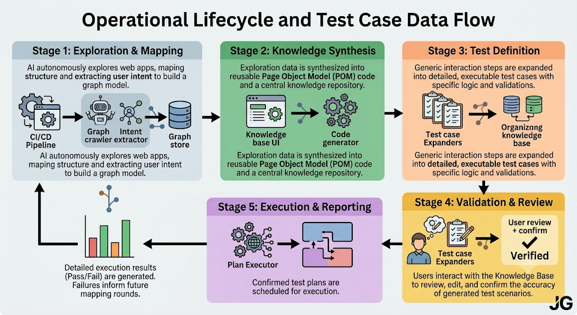

Features/ Steps in the Invention
Below are the steps/features performed in the invention:
- Autonomous Intent-Aware UI Exploration Engine: An AI-driven crawler that autonomously understands application intent and systematically explores all possible UI workflows using deterministic navigation.
- Composite UI State Fingerprinting and Knowledge Graph: A mechanism that uniquely identifies dynamic application states and maintains an evolving knowledge graph of UI pages, transitions, and metadata.
- Adaptive Decision and Continuous Learning Framework: A confidence-based decision engine that selectively invokes AI, reuses validated decisions, and continuously improves exploration through execution feedback.
- Automated Multi-Language Test Artifact Generation: A framework that automatically generates resilient Page Object Models (POMs) and executable test scripts for multiple programming languages from the discovered application model.

List of Prior Arts
Sl. No | Publication/ Patent Number | Title
1 | CN122173072A & CN122173072B | Mobile software automation method based on semantic knowledge graph and LLM enhanced reasoning
2 | CN122594138A | Automatic test method, device, storage medium, apparatus and program product
3 | JP7874373B1 | Web application operation support system, method, and program
4 | CN121908034A | Method and system for detecting compliance of television page

Mapping of Prior Arts

Sl. No | Bibliographic Information | Relevant portions from Prior Art | Features of the invention | IP Team Comments
1 | CN122173072A & CN122173072B  Mobile software automation method based on semantic knowledge graph and LLM enhanced reasoning  Current Assignee: BEIJING UNIV OF CHEMICAL TECHNOLOGY  Application Date: 11-Mar-2026 | The present invention relates to the field of artificial intelligence,software automation (Software Automation) and mobile computing technologies, and in particular, to a mobile software automation method, apparatus, electronic device, computer readable storage medium and computer program product based on semantic knowledge graph and LLM enhanced reasoning.  More particularly, the invention relates to a mobile application Graphical User Interface (GUI) automation technology including automation testing, task script execution and exploratory interactions, knowledge graph construction and application technology, knowledge modeling methods used in software engineering to represent user interface structures, component semantics and interaction logic, reasoning and decision applications in software automation involving Large Language Models (LLMs) including how to understand interface semantics, parse user intent and generate reliable operation sequences using LLMs, and cross-application, multi-step mobile end task automation technology aimed at solving end-to-end operation execution problems under conditions of interface dynamic changes, lack of stable API interfaces. The present invention aims to provide an intelligent autonomous automation solution for mobile applications that is capable of adapting to interface changes without relying on source code, requiring no predefined scripts or fixed APIs. | 1, 2, 3 | Automatically explores an application interface, constructs/enriches a semantic knowledge graph, uses an LLM for semantic reasoning, performs graph based path planning and provides a closed loop from instruction analysis through execution monitoring.
2 | CN122594138A  Automatic test method, device, storage medium, apparatus and program product  Current Assignee: GUANGZHOU BOGUAN INFORMATION SCIENCE & TECHNOLOGY Co.,Ltd.  Application Date: 9-May-2026 | The application discloses an automatic test method, device, storage medium, equipment and program product, which comprises the steps of processing test instructions based on a knowledge graph and/or an experience library to generate a test operation sequence, constructing the knowledge graph based on a result obtained by carrying out semantic analysis on data of test operation, wherein the knowledge graph at least comprises page nodes, element nodes and conversion relations among the nodes, the experience library is used for storing semantic vectors of the operation sequence and corresponding operation steps, executing the test operation sequence, and supporting test instruction processing through the knowledge graph and the experience library together to realize structural expression (knowledge graph) and semantic understanding (experience library) of test logic, overcome the limitation of relying on fixed scripts, improve test efficiency to meet test requirements, and improve the semantic understanding capability and self-adaptive decision capability of a test system. | 2, 3, 4 | Constructs a knowledge graph containing page/element nodes, uses an experience library containing semantic vectors and operation sequences, generates test-operation sequences and supports adaptive test decisions rather than fixed scripts.
3 | JP7874373B1  Web application operation support system, method, and program  Application Date: 16-Feb-2026 | To provide a web application operation support system, method, and program that can continue to operate even after a change in UI structure. [Solution] The method includes the steps of: acquiring the structure and operable elements of each page of a target web application; describing each page as structured metadata consisting of multiple categories including subject, operation type, target area, constraints, and context; extracting and associating semantically identifiable features for each operable element in addition to location information; saving the metadata in a referable format; and enabling continuous operation even after a change in UI structure by having a processing means operating in the user's browser environment convert the user's natural language input into the same format as the structured metadata, and when identifying an operable element by referring to the metadata, searching for similar elements using semantically identifiable features if the search using location information fails. | 1, 2 | Acquires operable elements of application pages, creates structured metadata representing pages, semantically identifies UI elements and supports continued operation despite changes in UI structure. This is relevant to resilient application exploration and UI representation.
4 | CN121908034A  Method and system for detecting compliance of television page | The invention discloses a method and a system for detecting the compliance of a television page, which are characterized in that a television page resource identification tree is constructed, a television page with a complex and various structures is converted into a hierarchical structured model, the steps of controlled acquisition of the television page, structured modeling of page information, compliance judging rule generation and management, sandbox execution, detection report generation and the like are abstracted into services which can be called by an MCP protocol, and automatic arrangement of detection tasks and automatic generation of judging scripts are realized through an intelligent agent, so that the intelligent compliance detection of the detected television page is realized, and the problems that the monitoring requirements of the complex and various television pages and dynamic update cannot be adapted in the prior art are effectively solved. | 1, 2, 4 | Automatically acquires pages, converts complex page structures into hierarchical structured models and uses an intelligent agent to arrange detection tasks and automatically generate judging scripts for execution.

Additional reference(s): For quick look

